Steps to create an account in ‘SAS OnDemand for Academics’:
- Go to the url: https://odamid.oda.sas.com/SASODARegistration/
- Fill the required details and submit – Please use your personal email id as it is for academic purposes – Do not use mu-sigma mail ID
- Verify and activate your account
- Go to https://odamid.oda.sas.com and login using the username sent to your email – Your account might take few hours to get processed and then you should be able to login
- You will be redirected to https://odamid.oda.sas.com/SASODAControlCenter/
- Click on SAS Studio

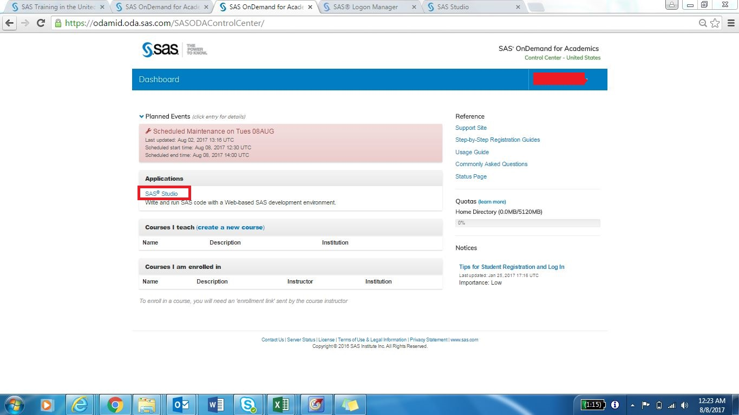

- This will open the interface

